**Team 11 - Web App Report**

**Program Instructions:**

The web app does use libraries and have dependencies. To ensure a functional use, please run the following commands:

npm i [this installs the dependencies]

npm run build [this is the compiler, and builds the app]

npm run start [this runs the webapp]

The installed node.js must be at version 12.22 at least to run this. Additionally, there may be another install requested upon npm run build, but this install is enough to allow it to run. This extra install only will appear with the correct node.js version.

More information regarding these dependencies, if necessary, can be found in README.MD.

**Contribution:**

Zachary Robinson - SQL Transaction Programming, Normalization Process, and ER Design

Hugh Hoang - ER Design, Instancing Database on Server, SQL Transaction Programming

Jana Tahan - Web App Development, JavaScript Implementation

**ER Design Evolution:**

Rough Er Diagram

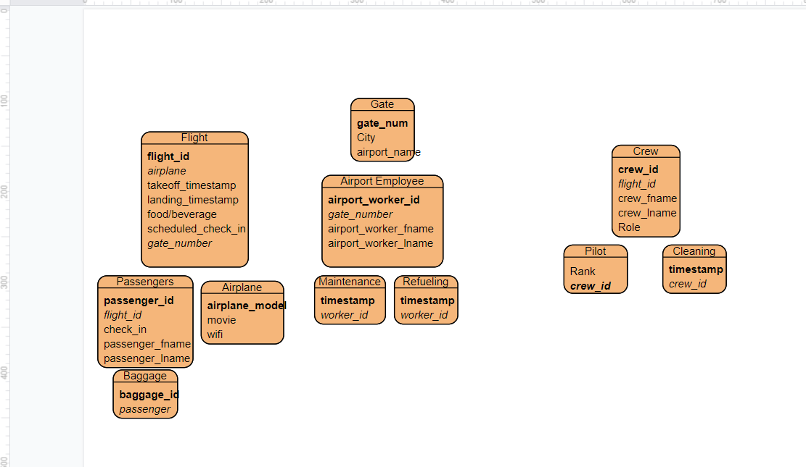

Intermediate ER Design

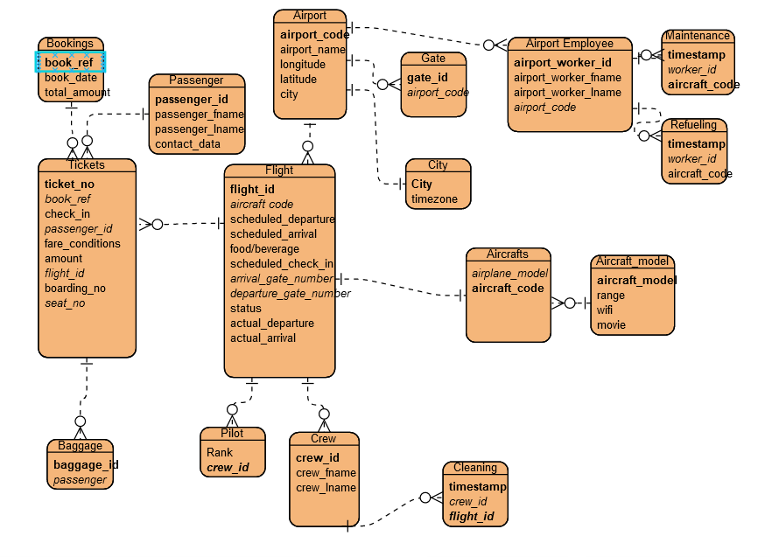

Final Er Diagram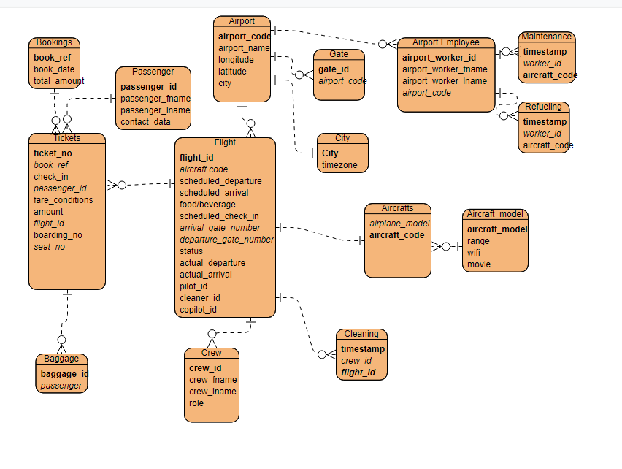

The above three ER diagrams show the progress made while designing the database. In the first, rough iteration, the tables were simple and based exclusively on the target assignment requirements. The second, intermediate iteration, was based on the Russian Airline schema, incorporating the target assignment requirements into the base Russian Airline. Additionally, normalization occurred here as some tables like “seat” and “ticket_flight” from the Russian airline were found to be unnecessary for our case and also needlessly violating BCNF. With this new implementation, almost all tables are in BCNF, except Airport, which is actually in 2NF. The violation came from longitude and latitude determining the city, but it seemed impractical to have a table exclusively for longitude and latitude as they are not important to the operation by themselves but in context of the airport, and having a table with a combination of all relevant longitude and latitudes connected to cities seemed redundant with the City table existing connecting cities to timezones. In the final version, the main changes revolved around the Crew and Flight tables. Pilot was removed and incorporated into Crew, and now each flight has its own pilot, co-pilot, and cleaner.

Main changes between the Russian Airline database and the one implemented here is the use of Gate, which stores each gate so that flights do not conflict with each other, City, which holds the names of relevant cities and their timezone, Baggage, which keeps track of all baggage for the passengers, and then Crew and Airport Employee, who are workers for the airline. Crew consists of pilots, co-pilots, and cleaners who have specific cleaning times in Cleaning, and members of Airport Employee sign up for times in Refuelling and Maintenance.

**Web App Development:**

The Web App part of the project in JavaScript was developed using frameworks and libraries such as Next.js and pg.promise. pg.promise is an API for JavaScript that allows minimum SQL alterations when using JavaScript, by passing in parameters directly with a file of SQL code with the QueryFile class. The API developed for this web application uses this for all interactions with the database. The frontend aspect of the app sends this API all user-inputed data to be used as parameters for pg.promise. Queries are used to verify the transaction is committed successfully for the user. Forms are implemented with a form switcher of sorts that makes it much easier for the user to use the app efficiently.

**Transactions:**

The web application has 8 main operations for users. Firstly, it can input new flights, inserting no flights that have the same destination or arrival gate at the same time. Secondly, this new flight will be assigned an aircraft from the available pool at a given time. Similarly, the flight will generate a pilot, co-pilot, and cleaner for the flight from the available crew members. For cleaners, they can schedule specific times to clean the aircraft on their flight, while airport workers can also schedule specific times to perform refueling and maintenance between flights. The site is able to check passengers in upon arriving at the gate of their flight, as well as check in all of the necessary baggage and remove baggage when retrieved by the passenger. The actual takeoff and arrival times can also be recorded so that it can be compared with the scheduled times. There are additional queries as well such as filtering whether certain aircrafts have a specific type of entertainment (wifi/movie). Transactions/Queries for the above defined operations can be found below.

The transactions for the above operations can be found below:

* **Input new flights and ensure no conflicts with gate numbers at a certain time, assigning an aircraft and crew members**

**BEGIN;**

**SET TRANSACTION ISOLATION LEVEL SERIALIZABLE;**

**do $$**

**DECLARE**

**possible_departure_gate VARCHAR(6) := 'CLTJKE';**

**possible_arrival_gate VARCHAR(6) := 'DFWQWE';**

**possible_departure_time TIMESTAMP := '2021-08-18 13:57:40';**

**possible_arrival_time TIMESTAMP := '2021-08-18 16:12:00';**

**possible_food VARCHAR(20) := 'CHICKEN';**

**possible_check_in TIMESTAMP := '2021-08-18 12:00:00';**

**currentFlightID VARCHAR(5) := 'AT128';**

**/*the above variables should be inserted by the website user, these are hardcoded in for readability and debugging in SQL*/**

**possiblePilot INTEGER := 635;**

**possibleCopilot INTEGER := 917;**

**possibleCleaner INTEGER := 459;**

**p_status VARCHAR(10) := 'ONTIME';**

**flightAircraft VARCHAR(4) := '-';**

**Taken_Count INTEGER := -1;**

**validOrder BOOLEAN := True;**

**validCheckIn BOOLEAN := True;**

**begin**

**/*This checks and ensures the departure is before arrival*/**

**IF (possible_departure_time - possible_arrival_time) > '0 seconds' THEN validOrder := False; END IF;**

**/*This checks that the check in time is an acceptable distance from the planned departure*/**

**IF (possible_check_in - possible_departure_time) < '-4 hours' OR (possible_check_in - possible_departure_time) > '-1 hour' THEN validCheckIN := False; END IF;**

**/*This searches through aircrafts to find one that is available for this flight*/**

**SELECT aircraft_code INTO flightAircraft**

**FROM Aircraft**

**EXCEPT**

**SELECT aircraft_code**

**FROM( SELECT aircraft_code, scheduled_arrival**

**FROM Flight) as aircraftTest**

**WHERE (scheduled_arrival - possible_departure_time) < '1 day' AND (scheduled_arrival - possible_departure_time) > '-1 day'**

**LIMIT 1;**

**/*This searches through crew members who are pilots to find one that is available for this flight*/**

**SELECT crew_id INTO possiblePilot**

**FROM Crew**

**WHERE role = 'Pilot'**

**EXCEPT**

**SELECT pilot_id**

**FROM ( SELECT pilot_id, scheduled_arrival**

**FROM Flight) as pilotTest**

**WHERE (scheduled_arrival - possible_departure_time) < '1 day' AND (scheduled_arrival - possible_departure_time) > '-1 day'**

**LIMIT 1;**

**/*This searches through crew members who are copilots to find one that is available for this flight*/**

**SELECT crew_id INTO possibleCopilot**

**FROM Crew**

**WHERE role = 'Copilot'**

**EXCEPT**

**SELECT copilot_id**

**FROM( SELECT copilot_id, scheduled_arrival**

**FROM FLight) as copilotTest**

**WHERE (scheduled_arrival - possible_departure_time) < '1 day' AND (scheduled_arrival - possible_departure_time) > '-1 day'**

**LIMIT 1;**

**/*This searches through crew members who are cleaners to find one that is available for this flight*/**

**SELECT crew_id INTO possibleCleaner**

**FROM CREW**

**WHERE role = 'Cleaner'**

**EXCEPT**

**SELECT cleaner_id**

**FROM( SELECT cleaner_id, scheduled_arrival**

**FROM Flight) as cleanerTest**

**WHERE (scheduled_arrival - possible_departure_time) < '1 day' AND (scheduled_arrival - possible_departure_time) > '-1 day'**

**LIMIT 1;**

**/*This searches through all flights to ensure there is no other conflicting flights at the proposed gates at the given times*/**

**SELECT COUNT(*) into Taken_Count**

**FROM (SELECT flight_id**

**FROM Flight**

**WHERE (departure_gate_number = possible_departure_gate**

**AND ((possible_departure_time - scheduled_departure) <= '1 hour' AND (possible_departure_time - scheduled_departure) >= '-1 hour'))**

**OR (arrival_gate_number = possible_arrival_gate**

**AND ((possible_arrival_time - scheduled_arrival) <= '1 hour' AND (possible_arrival_time - scheduled_arrival) >= '-1 hour'))) AS invalid_flight;**

**/*Only insert the flight if all the checks were true*/**

**IF Taken_Count = 0 AND validOrder = TRUE AND validCheckIn = True THEN**

**INSERT INTO Flight**

**VALUES (currentFlightID, flightAircraft, possible_departure_time, possible_arrival_time, possible_food, possible_check_in, possible_arrival_gate, possible_departure_gate, p_status, NULL, NULL, possiblePilot, possibleCopilot, possibleCleaner);**

**END IF;**

**end;**

**$$;**

**COMMIT;**

* **Schedule cleaning, refueling, and maintenance for crew attendants and workers**

**/*Assume an employee is signing up for a specific cleaning time, check and see if that time is not already taken...**

**BEGIN;**

**SET TRANSACTION ISOLATION LEVEL SERIALIZABLE;**

**do $$**

**DECLARE**

**given_flight_id VARCHAR(5) := 'AC512';**

**possible_cleaning TIMESTAMP := '2021-01-09 12:40:20';**

**Taken_Count INTEGER := -1;**

**validTime BOOLEAN := True;**

**/*the above variables should be inserted by the website user, these are hardcoded in for readability and debugging in SQL*/**

**beginTime TIMESTAMP := '1900-01-01 12:00:00';**

**endTime TIMESTAMP := '1900-01-01 12:00:00';**

**begin**

**/*find the given flight’s scheduled_departure*/**

**SELECT scheduled_departure INTO beginTime**

**FROM Flight**

**WHERE flight_id = given_flight_id;**

**/*find the given flight’s scheduled_arrival*/**

**SELECT scheduled_arrival INTO endTime**

**FROM Flight**

**WHERE flight_id = given_flight_id;**

**/*check and ensure the given cleaning time is actually during the scheduled time of the flight*/**

**IF (possible_cleaning < beginTime) OR (possible_cleaning > endTime) THEN validTime := False; END IF;**

**/*count and ensure this is not too close to a previously inserted cleaning time*/**

**SELECT COUNT(*) INTO Taken_Count**

**FROM (SELECT cleaning_time, flight_id**

**FROM Cleaning**

**WHERE (((possible_cleaning - cleaning_time) <= '30 minutes' AND (possible_cleaning - cleaning_time) >= '-30 minutes') AND given_flight_id = flight_id)) AS T;**

**/*if the following checks come out true, the insert the proposed cleaning shift*/**

**IF Taken_Count = 0 AND validTime = True THEN**

**INSERT INTO Cleaning**

**VALUES (possible_cleaning, given_flight_id);**

**END IF;**

**end; $$;**

**COMMIT;**

**------------------------------------------------------------------------------------------------------------**

**This is a separate transaction for maintenance:**

**BEGIN;**

**SET TRANSACTION ISOLATION LEVEL SERIALIZABLE;**

**do $$**

**DECLARE**

**given_aircraft_code VARCHAR(4) := 'B421';**

**given_maintenance_time TIMESTAMP := '2021-09-01 3:00:00';**

**given_worker_id INTEGER := '123';**

**/*the above variables should be inserted by the website user, these are hardcoded in for readability and debugging in SQL*/**

**previous_time TIMESTAMP := '1990-01-01 12:00:00';**

**next_time TIMESTAMP := '2999-01-01 12:00:00';**

**TakenCount INTEGER := -1;**

**busyCounter INTEGER := -1;**

**begin**

**/*this checks if the proposed airport worker is busy with another job*/**

**SELECT COUNT(*) INTO busyCounter**

**FROM Refueling**

**WHERE (given_maintenance_time - refuel_time) <= '20 minutes' AND (given_maintenance_time - refuel_time) >= '-20 minutes' AND worker_id = given_worker_id;**

**/*this finds the most recent flight with the given aircraft/\***

**SELECT MAX(scheduled_arrival) INTO previous_time**

**FROM( SELECT flight_id, scheduled_arrival**

**FROM Flight**

**WHERE scheduled_arrival < given_maintenance_time) AS T1;**

**/*this finds the next flight with this give aircraft/\***

**SELECT MIN(scheduled_departure) INTO next_time**

**FROM( SELECT flight_id, scheduled_departure**

**FROM Flight**

**WHERE scheduled_departure > given_maintenance_time) AS T2;**

**/*if either of these are NULL, put a placeholder for the tests to run effectively*/**

**IF next_time IS NULL**

**THEN next_time := '2999-01-01 12:00:00';**

**END IF;**

**IF previous_time IS NULL**

**THEN previous_time := '1990-01-01 12:00:00';**

**END IF;**

**/*check there is not already a maintenance job between the aircrafts’ flights*/**

**SELECT COUNT(*) INTO TakenCount**

**FROM Maintenance**

**WHERE maintenance_time >= previous_time AND maintenance_time <= next_time AND given_aircraft_code = aircraft_code;**

**/*insert the shift as long as the above tests succeed*/**

**IF TakenCount = 0 AND busyCounter = 0**

**THEN INSERT INTO Maintenance**

**VALUES (given_maintenance_time,given_worker_id, given_aircraft_code);**

**END IF;**

**end; $$;**

**COMMIT;**

**------------------------------------------------------------------------------------------------------------**

**This is a separate transaction for refuelling:**

**BEGIN;**

**SET TRANSACTION ISOLATION LEVEL SERIALIZABLE;**

**do $$**

**DECLARE**

**given_aircraft_code VARCHAR(4) := 'B512';**

**given_refuel_time TIMESTAMP := '2021-09-01 3:00:00';**

**given_worker_id INTEGER := '123';**

**/*the above variables should be inserted by the website user, these are hardcoded in for readability and debugging in SQL*/**

**previous_time TIMESTAMP := '1990-01-01 12:00:00';**

**next_time TIMESTAMP := '2999-01-01 12:00:00';**

**TakenCount INTEGER := -1;**

**busyCounter INTEGER := -1;**

**begin**

**/*check and ensure the given airport worker is not busy with another job*/**

**SELECT COUNT(*) INTO busyCounter**

**FROM Maintenance**

**WHERE (given_refuel_time - maintenance_time) <= '20 minutes' AND (given_refuel_time - maintenance_time) >= '-20 minutes' AND worker_id = given_worker_id;**

**/*find the previous flight with this aircraft*/**

**SELECT MAX(scheduled_arrival) INTO previous_time**

**FROM( SELECT flight_id, scheduled_arrival**

**FROM Flight**

**WHERE scheduled_arrival < given_refuel_time) AS T1;**

**/*find the next flight with this aircraft*/**

**SELECT MIN(scheduled_departure) INTO next_time**

**FROM( SELECT flight_id, scheduled_departure**

**FROM Flight**

**WHERE scheduled_departure > given_refuel_time) AS T2;**

**/*if either of these are NULL, put a placeholder for the tests to run effectively*/**

**IF next_time IS NULL**

**THEN next_time := '2999-01-01 12:00:00';**

**END IF;**

**IF previous_time IS NULL**

**THEN previous_time := '1990-01-01 12:00:00';**

**END IF;**

**/*check there is not already a refuel job between the aircrafts’ flights*/**

**SELECT COUNT(*) INTO TakenCount**

**FROM Refueling**

**WHERE refuel_time >= previous_time AND refuel_time <= next_time AND given_aircraft_code = aircraft_code;**

**/*insert the shift as long as the above tests succeed*/**

**IF TakenCount = 0 AND busyCounter = 0**

**THEN INSERT INTO Refueling**

**VALUES(given_refuel_time, given_worker_id, given_aircraft_code);**

**END IF;**

**end; $$;**

**COMMIT;**

* **Check in customers when they arrive at their flight**

**BEGIN;**

**SET TRANSACTION ISOLATION LEVEL SERIALIZABLE;**

**do $$**

**DECLARE**

**given_ticket_no INTEGER := 100001;**

**given_timestamp TIMESTAMP := '2020-08-09 12:00:00';**

**/*the above variables should be inserted by the website user, these are hardcoded in for readability and debugging in SQL*/**

**begin**

**/*update the check_in time based on the given timestamp*/**

**UPDATE Tickets SET check_in = given_timestamp WHERE ticket_no = given_ticket_no;**

**end; $$;**

**COMMIT;**

* **Manage baggage for each customer**

**BEGIN;**

**SET TRANSACTION ISOLATION LEVEL SERIALIZABLE;**

**do $$**

**DECLARE**

**given_baggage_id INTEGER := 399214;**

**given_passenger_id VARCHAR(6) := 'HCF99K';**

**check_in_or_out BOOLEAN := 'False'; /*false means check out, true means check in*/**

**/*the above variables should be inserted by the website user, these are hardcoded in for readability and debugging in SQL*/**

**TakenCount INTEGER := -1;**

**Begin**

**/*check the amount of baggage present that matches the ID given; this will only be ever 0 or 1*/**

**SELECT COUNT(*) INTO TakenCount**

**FROM (SELECT baggage_id**

**FROM Baggage**

**WHERE (baggage_id = given_baggage_id)) AS invalid_baggage;**

**/*if there is no matching bag and the user wants to insert, then insert and if**

**if there is a matching bag and the user wants to remove, then remove*/**

**IF TakenCount = 0 AND check_in_or_out = True**

**THEN INSERT INTO Baggage**

**VALUES(given_baggage_id, given_passenger_id);**

**ELSIF TakenCount = 1 AND check_in_or_out = False**

**THEN DELETE FROM Baggage WHERE given_baggage_id = baggage_id;**

**END IF;**

**end; $$;**

**COMMIT;**

* **Record actual takeoff and arrival times**

**Departure:**

**BEGIN;**

**SET TRANSACTION ISOLATION LEVEL SERIALIZABLE;**

**do $$**

**DECLARE**

**given_flight_id VARCHAR(5) := 'AT128';**

**given_timestamp TIMESTAMP := '2021-08-18 14:00:00';**

**/*the above variables should be inserted by the website user, these are hardcoded in for readability and debugging in SQL*/**

**begin**

**/*assuming the times are NULL, then update the flight with the actual departure*/**

**UPDATE Flight SET actual_departure = given_timestamp WHERE flight_id = given_flight_id AND actual_departure IS NULL;**

**end; $$;**

**COMMIT;**

**---------------------------------------------------------------------------------------------------------------------**

**Arrival:**

**BEGIN;**

**SET TRANSACTION ISOLATION LEVEL SERIALIZABLE;**

**do $$**

**DECLARE**

**given_flight_id VARCHAR(5) := 'AT128';**

**given_timestamp TIMESTAMP := '2021-08-18 16:17:31';**

**/*the above variables should be inserted by the website user, these are hardcoded in for readability and debugging in SQL*/**

**begin**

**/*assuming the times are NULL, then update the flight with the actual arrival*/**

**UPDATE Flight SET actual_arrival = given_timestamp WHERE flight_id = given_flight_id AND actual_arrival IS NULL;**

**end; $$;**

**COMMIT;**

* **Filter whether aircrafts have entertainment**

**/*$1 refers to the the users’ preference on movie (true if movies must be present) and $2 refers to the users’ preference of wifi (true if wifi must be present)*/**

**SELECT * FROM Aircraft JOIN Aircraft_Model ON Aircraft_Model.aircraft_model = Aircraft.Aircraft_Model**

**WHERE (($1 = true AND wifi = true) OR $1 = false) AND (($2 = true AND movie = true) OR $2 = false);**

There are also queries used to check the results of the transactions above. These test for the primary key (or what was changed in the case of the UPDATE transactions). These include the following checks:

* **new_flight_transaction_q**

**/*currentFlightID is the value given by the user; this should result with 1*/**

**SELECT COUNT (*)**

**FROM Flight**

**WHERE currentFlightID = flight_id**

* **assign_clean_shift_q**

**/*possible_cleaning and given_flight_id are values given by the user; this should result with 1*/**

**SELECT COUNT(*)**

**FROM Cleaning**

**WHERE possible_cleaning = cleaning_time AND given_flight_id = flight_id**

* **assign_maintenance_shift_q**

**/*given_maintenance_time and given_aircraft_code are values given by the user; this should result with 1*/**

**SELECT COUNT(*)**

**FROM Maintenance**

**WHERE given_maintenance_time = maintenance_time AND given_aircraft_code = aircraft_code**

* **assign_refuel_shift_q**

**/*given_refuel_time and given_aircraft_code are given by the user; this should result with 1*/**

**SELECT COUNT(*)**

**FROM Refueling**

**WHERE given_refuel_time = refuel_time AND given_aircraft_code = aircraft_code**

* **baggage_manager_q**

**/*given_baggage_id is the value inserted by the user; this should result with 1 if checked in baggage, and 0 if checked out baggage*/**

**SELECT COUNT(*)**

**FROM Baggage**

**WHERE given_baggage_id = baggage_id**

* **ticket_checkin_q**

**/*given_ticket_no and given_timestamp are values inserted by the user; this should result with 1*/**

**SELECT COUNT (*)**

**FROM Tickets**

**WHERE given_ticket_no = ticket_no AND given_timestamp= check_in**

* **record_departure_q**

**/*given_flight_id and given_timestamp are values inserted by the user; this should result with 1*/**

**SELECT COUNT(*)**

**FROM Flight**

**WHERE given_flight_id= flight_id AND given_timestamp = actual_departure**

* **record_arrival_q**

**/*given_flight_id and given_timestamp are values inserted by the user; this should result with 1*/**

**SELECT COUNT(*)**

**FROM Flight**

**WHERE given_flight_id = flight_id AND actual_arrival = given_timestamp**

Demo video

<https://www.dropbox.com/sh/267dlln90er7c0y/AACYNLHEVHOh9Hm_S4PEbnvCa?dl=0>